Please answer all the questions accordingly and submit the solution.

**Suppose we have a database table named "employees" with the following schema:**

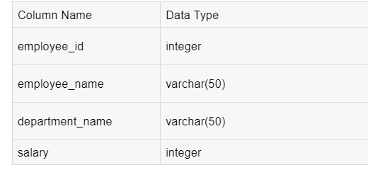

**Let's assume that this table contains data for a company's employees, where each employee has a unique employee_id, a name, a department they belong to, and a salary they earn.**

**Ques 1-Create a table with the name ‘employee’ and insert at least 10 records in it.**

**Ques 2-Find out the top 3 highest paid employees in each department.**

**Ques 3-Extract the average salary in each department along with all the details of the employee table.**

**Ques 4-Write a query to check if the salary of an employee is higher, lower, or equal to the salary of a previous employee**

**Ques 5-Display all the details of the employee table along with usage of rank, dense rank, and row number function based on salaries arranged in descending order**